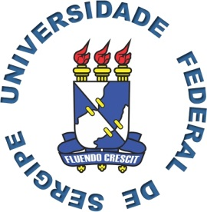
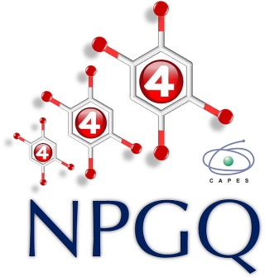
PALESTRA
TÍTULO: "HIGH-FREQUENCY AND -FIELD ELECTRON PARAMAGNETIC RESONANCE (HFEPR) SPECTROSCOPY OF HIGH-SPIN TRANSITION METAL ION COMPLEXES: NEWEST DEVELOPMENTS”

PALESTRANTE: Prof. Dr. Joshua Telser –Department of Biological, Chemical and Physical Sciences Roosevelt University, Chicago, USA.
LOCAL: Did. V, Sala 102
DATA: 27/03/2014 (quinta-feira)
HORÁRIO: 14h30m
Convidam-se os interessados

